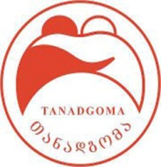
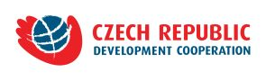
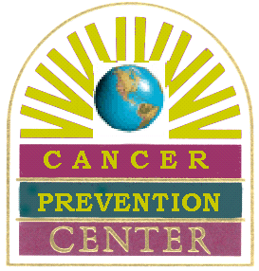
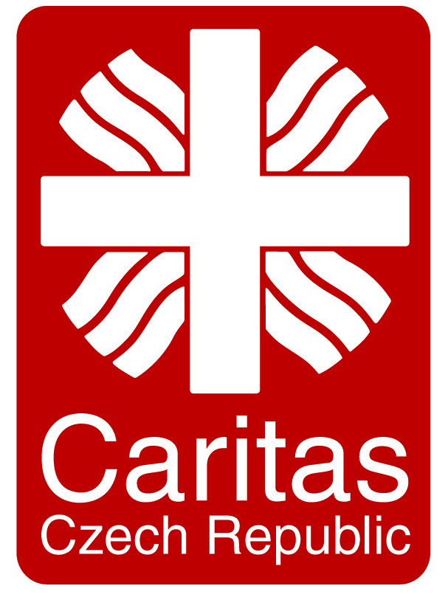
March 15, 2016, Tbilisi

PRESS RELEASE

Together Against the Cancer!

In the frame of Project “Oncologic Education of Family Doctors” intensive training course for family/village doctors on the issues of Cancer Prevention and Early Detection is starting up

On March 18, 2016, at the National Center for Disease Control and Public Health of the Ministry of Labour, Health and Social Affairs of Georgia will start the training course for family doctors on the issues of oncology. The training will be delivered by Czech and Georgian Experts in the field. During this year similar trainings will be organized for the representatives of primary health sector in Tbilisi, Samegrelo-Zemo Svaneti and Guria.

The aim of the trainings is to strengthen engagement of primary health workers in the prevention and early detection of cancer, palliative care. At the meeting the participants will discuss meaning of “oncological Alertness” of primary health sector, situation in Georgia, National Strategy on Cancer Control and Czech experiences.

The event is planned in the frame of the project under Memorandum of Understanding (“Support of Early Diagnosis, Prevention and Treatment of Oncological Diseases”) between Czech Development Agency and Ministry of Labour, Health and Social Affairs of Georgia, being implemented by Caritas Czech Republic in Georgia and Cancer Prevention Center.

The representatives of Project donor Czech Development Agency, Embassy of Czech Republic in Tbilisi, MoLHSA, NCDC will attend the event.

Meeting venue and time: NCDC, 9 Asatiani Str,. Tbilisi. March 18, 2016, at 15:00

General Data: According to WHO, Cancer is one of the leading causes of morbidity and mortality worldwide and its indicator is increasing annually. By official Data, in Georgia in 2015 around 9000 new cancer cases were identified. The effective approach of cancer control is prevention and early detection which includes active engagement of primary health workers in this process as well as education of the population about healthy life-style and importance of early detection.

Information about the project: Caritas Czech Republic in Georgia, Caner Prevention Center and Information Center Tanadgoma have been implementing projects on cancer prevention and early detection since 2010. Current project “Oncologic Education of Family Doctors” is based on above mentioned approach: on one hand, promoting role of primary health sector in the cancer control strategy and on another hand, raising awareness of the population on this issue.

For more information about the project contact Caritas Czech Republic in Georgia
Tamar Kurtanidze, Project Manager tamar.kurtanidze@caritas.cz 593 314504
ww.charita.cz https://www.facebook.com/CCRGeorgia2015/

